Your task is to build an integration and processing system for Wikipedia / Wikimedia.

Your task is to add integration with the Wiki Recent Change API (wikimedia endpoint link) (alternatively - WikiMedia Event Stream API).

As a part of that task, you should design an API that let:
- Get all Recent Changes as a realtime stream
- Track in real-time the activity of a particular user or a set of users
- Retrieve a statistic of a particular user which include:
  - Information about user contribution as a series of points over time. (Wikipedia User Contribution can be gathered as X Y data points (where X is time and Y is a total number of contribution at that point in time. As an example of such may be taken the following graphic of a user contribution for a Github project
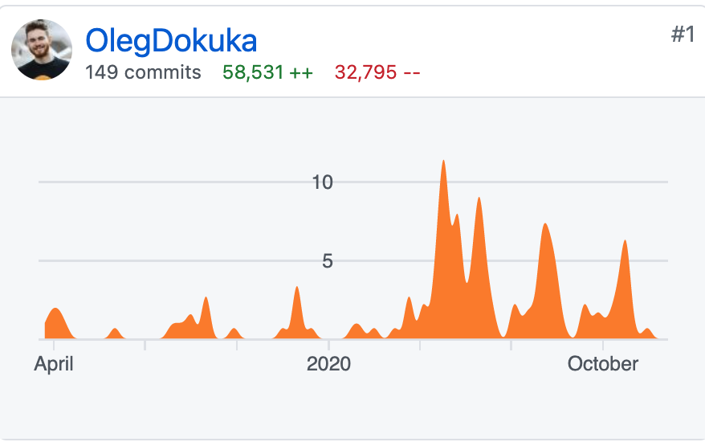
Note, the API should allow one to specify time granularity in which the series should be returned
  - Topics to which user has contributed most
  - Type of contribution (typos editing | content addition). Type of contribution should be exposed as absolute numbers so one can guess whether the user helps with adding new facts or mostly with copyediting.
- Retrieve most active user during the (YEAR|MONTH|DAY)
- Retrieve the top 10 topics which have the most number of typo editings
- Optional: Retrieve the word in which user do mistake most of the time

Acceptance Criteria

- Design Project Architecture and present it. Explain the reasons why the specific approach was selected.
- Explain data flow on the sequence diagram
- Implement core logic and makes sure that it meets quality criteria (test coverage, manual verification)
- Explain the reasons, why a specific implementation approach was selected

